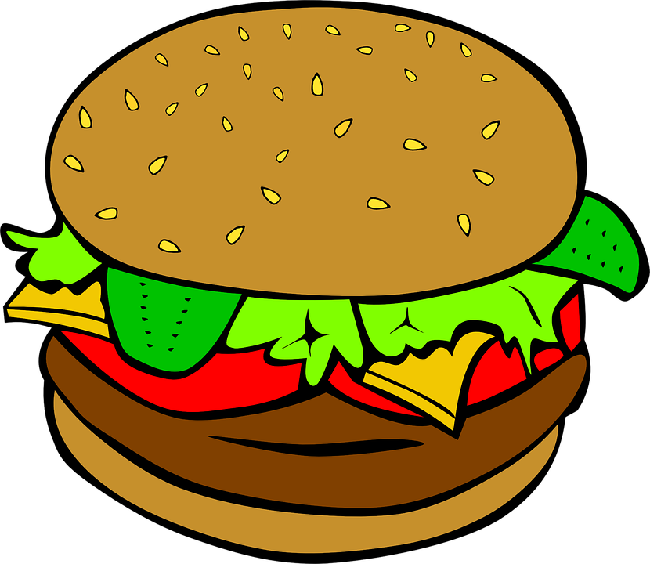
SQUIRREL RUN GOLF CLUB

ALL INCLUSIVE OUTING PRICING
INCLUDES: 18 HOLES GOLF CART DINNER

RED TEE PACKAGE  $50  Select 1 Entrée  Cheeseburgers  BBQ or Grilled Chicken  BBQ Pulled Pork  Ziti & Meatballs | WHITE TEE PACKAGE  $60  Select 1 Entrée  Chicken Piccata  Chicken Marsala  Pork Tenderloin  Baked Ham  Turkey Tips | BLUE TEE PACKAGE  $65  Select 1 Entrée  Roast Beef W/Gravy  Roast Turkey W/Stuffing  8oz Steak

ALL PACKAGES INCLUDE 1 SALAD 1 POTATO 1 VEGETABLE
Salad
Tossed-Potato-Caesar
Potato
Baked-Roasted-Mashed
Vegetable
Medley-Corn-Green Beans-Glazed Carrots-Baked Beans

8AM OR 12:30 SHOTGUNS AVAILABLE -ONLY GOLF $30 ADD CART $40
Player count due 10 days before event!
Additional Options:

Boxed Lunch: Sandwich W/bag of chips $10.00 per person
Assorted Sandwiches: Ham, Turkey, Tuna Salad, and Chicken Salad

Appetizers: Cheese & Crackers with Vegetable Platter $3.50 per person
Choice of 2 Hot Apps $12.00 per person
Chicken Fingers, Mozzarella Sticks, Meatballs, Crab Rangoon’s

According to Massachusetts Law it is ILLEGAL to bring outside liquor on to the premises. OUTSIDE ALCOHOL AND COOLERS ARE NOT PERMITTED on the course or parking lot at any time. All outside alcohol may be CONFISCATED and the person with it may be asked to leave the premises.
32 Elderberry Drive, Plymouth Ma 02360

WWW.GOLFATSQUIRRELRUN.COM
Contact: 508-746-5001 or Email DAVIDLMOORE@PGA.COM

